Required results

|  |  |
| --- | --- |
| DD Beta for calls | 0.6335351151695856 |
| DD Beta for puts | 0.6961654663085934 |
| SABR Alpha | 0.9907772779928059 |
| SABR Rho | -0.2851471456675992 |
| SABR Nu | 0.35222714450687553 |

Implied volatility from market prices were extracted using the Displaced Diffusion (DD) model with Beta=1, equivalent to the Black-76 Lognormal option pricing model and plot as “Market-IV”.

Differing values of Betas were input into the DD model to estimate which Beta parameter would most closely represent the implied volatility observed in the market. The main challenge in fitting the model was that in attempting to fit the IV of the lower strikes, we have to accept a larger deviation in the IV of the higher strikes, and vice versa.

A least-squares method was used to find the Beta that would most closely fit market IV. This resulted in Beta parameters of approximately 0.6335 for calls and 0.6962 for puts. The two DD model lines are then plot below.

We note that while it does a sufficiently good job at matching higher strike IVs, it gives a poor fit for the IVs of the lower strikes.

The reason for this is that the market is pricing in a much higher IV value for lower strikes than these models suggest, likely due to behavioural reasons rooted in risk aversion, i.e. investors are willing to pay relatively high premiums for protection against large downside moves.

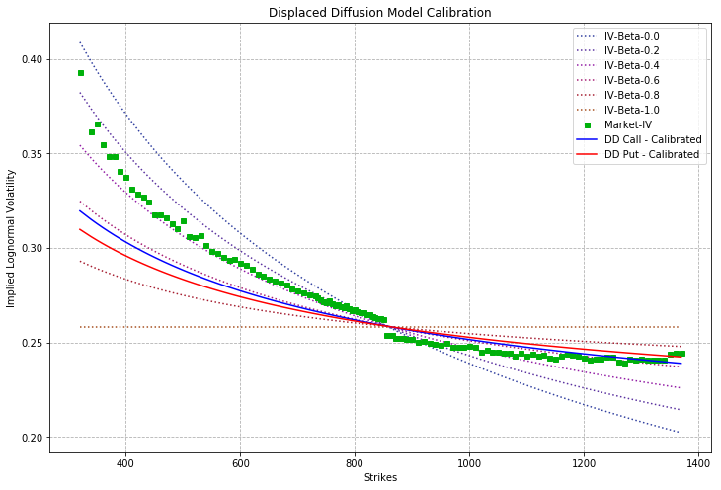

By visual estimation, we used the SABR model to fit the market IV.

Following which, we calibrated the SABR model using the least squares method and obtained the following parameters of Alpha, Rho, and Nu, while keeping Beta fixed at 0.8.

The calibrated SABR model fits the market IV very well, and this can be explained by the extra parameters which allow us to tweak the shape of the curve.

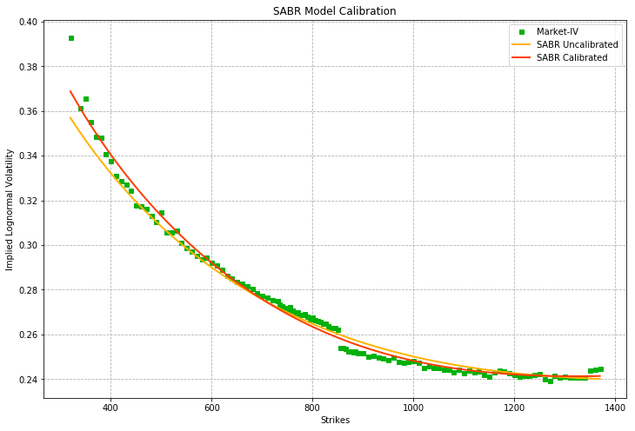

SABR Alpha

Alpha adjusts for the height of the curve, and represents the constant of the volatility parameter. It can be seen as a baseline IV that is built into all the option prices.

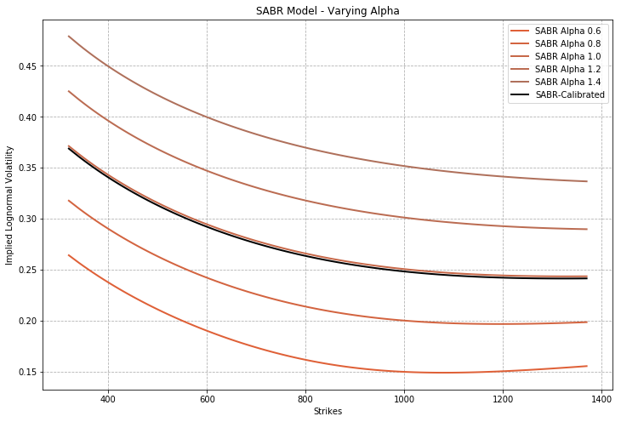

SABR Rho

In the Black-Scholes model, the volatility term is deterministic, whereas in the SABR model, volatility of returns are modelled as being correlated with stock returns.

Rho adjusts for the skew in the distribution of stock returns. Decreasing the Rho adjusts for a more negative skew in stock returns. This allows us to increase the IVs of the lower strikes (OTM puts) to a higher IV than what the Black-Scholes model would suggest, and decrease the IVs of the higher strikes (OTM calls).

Given that the calibrated correlation parameter is slightly negative, it implies that volatility increases when stock prices decrease.

The adjustment also accounts for the behavioural factor that investors are usually more worried about downside risks than upside risks, and thus are willing to pay relatively higher prices for OTM lower strike puts as compared to similarly distant higher strikes OTM calls.

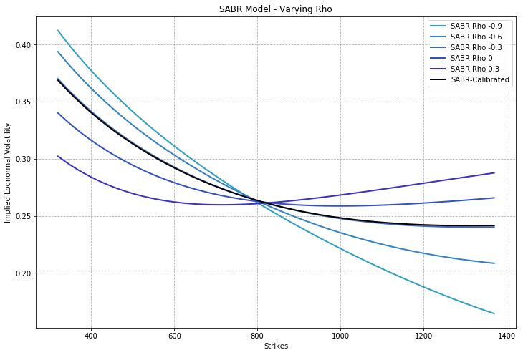

SABR Nu

Nu adjusts for the volatility of volatility, and is proportionate to the degree of kurtosis of stock returns. A higher value of Nu increases the IV (and thus prices) of both calls and puts.

This, coupled with a negative Rho value, leads to a much better curve that fits market prices and its corresponding expectations.

